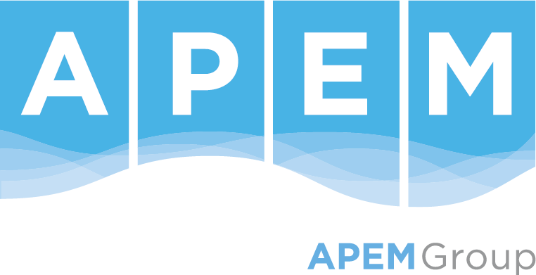

Job Description

Role title: Principal- Water Resources Management
Reports to: Associate Director
Grade: Principal
Sector: Water & Land
Division: Water Management
Location: Flexible
Purpose/ Scope of role
APEM’s Water Resources Management team continues to expand and is currently undertaking exciting projects in water resources, hydrology, hydrometry, drought, environmental assessment and management.
This is a great opportunity to work on a range of water projects such as water company drought and water resources plans, regional water resources plans, drought permit applications, monitoring programmes, associated assessments e.g., WFD Compliance Assessment, SEA, HRA. The role forms part of a wider dynamic team of multi-disciplinary water and environmental experts that includes specialists in the fields of water resources, hydro-ecology, hydrology, geomorphology, water quality, aquatic and terrestrial ecology, environmental impact assessment and planning.
The role will cover all aspects of the consultancy process from client liaison, bringing in new projects to offering authoritative technical guidance and production of high quality scientific reports.
What success looks like in this role
In the first six months you will assist others in aspects of project management, tender production, and financial management across our portfolio of water management work. These will include project reviews and technical guidance, business development, and client-facing capabilities, supported throughout by APEM’s highly experienced team of multi-disciplinary consultancy professionals.
In 12 months, you will be managing your own portfolio of projects, including large-scale projects with multiple teams, across different locations. You will likely have line management of a team of senior consultants and consultants and have responsibility for quality of the work delivered by the team as well as providing mentoring, supporting and guidance to your team. You will be providing expert advice in your area of expertise to a range of internal and external clients. You will be developing your own client network and actively winning new work. You will undertake client meetings, site visits and field surveys where required.

Key Responsibilities and accountabilities
- Identify potential opportunities and challenges in relation to APEM Group’s organisational goals and provide solutions;
- Acquire new contracts through a combination of networking, client relationships, tenders and opportunity development;
- Accountable for revenue generation, assessing, coordinating and contributing to tender opportunities, including tender preparation, costing and writing of technical sections;
- Responsible for project delivery within budget and to a high standard, which will likely include large, high profile or complex projects;
- Leading and inputting on the delivery of cross team/ divisional projects;
- Technical and reporting reviews to ensure APEM meets the highest technical standards and client aims and objectives;
- To take reasonable care for the health and safety of yourself and others; make use of the tools, equipment, training and resources; and actively engage with colleagues at all levels to contribute to the continuous improvement of health and safety management.
- Client liaison, including site visits and fieldwork, as required;
- Coaching, developing and mentoring team members.
Skills/ Knowledge/ Experience/ Qualifications
- MSc or equivalent experience in a relevant discipline (e.g., water resources management, hydrology, environmental science);
- Typically, at least 10 years’ professional experience, working across water resources management, drought planning, water related monitoring programmes and assessments e.g., WFD Compliance Assessment, HRA, Environmental Assessment Report (EAR), water cycle studies;
- A contemporary understanding of relevant key UK environmental legislation related to water resources planning, drought planning and associated environmental assessments;
- Proven track record in providing technical advice to clients and colleagues;
- Skilled at preparing high quality technical reports for a range of clients in the private and public sector;
- Excellent verbal and written communication skills;
- Organised and able to work to tight deadlines;
- Flexibility to manage changing priorities.

We are involved in a diverse range of work and therefore would be interested in hearing from applicants who have any of the below skills. However, we do not expect applicants to cover all these topics.
- Water resources planning (e.g., water supply and drought management);
- Water risk and security;
- Hydrometric data and analysis;
- Resilience and water management;
- Sustainability assessments, water cycle studies;
- Water level management;
- Environmental assessments, including HRA, SEA, WFD, EAR;
- Climate resilience;
- Scheme appraisal;
- Regulatory support.
Our Values
Our most important assets are our people who work here. We all work as one team and rely on each other. We wish to create a working environment to which our people are proud to belong, by maintaining our values at the forefront of everything we do. These values are:
- Integrity – We do the right thing;
- Quality – Quality in everything;
- People - We care;
- Forward thinking – We focus on the future;
- Positivity – We believe we can;
- Fairness – We champion equality.
Our WOW Factor
When home became work, we learned that flexibility, understanding and balance allowed us all to move forward and grow together. So, no matter where you’re based, the hours you keep, the toddlers you have to entertain, or outside interests that help with your wellbeing we’re committed to our Ways of Working (WOW) with each other so we can continue to be our best.
You belong
We recognise that everyone’s story is different. The opportunities, experiences and challenges faced in life shape who we are, and we understand that these are the things that make us individual and unique. Embracing our differences means we’re able to approach what we do from every angle.
Inspiration and insight can come from anywhere, and no matter your history or choices in life, we empower our people to be their best, so we can be our best, together. We welcome the whole you.

