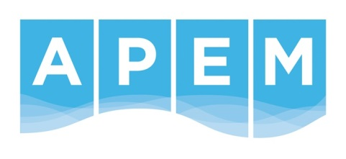

Role description

Role: People Administration Assistant
Reports into: Head of People Operations
Grade: Scientist
Location: Manchester - The role is hybrid
Team: People

Purpose / Scope of role
The People function is going through transformational change to facilitate the growing needs of the business. The People Administration Assistant will support this change by providing an exceptional People support function ensuring that People operational and legislative requirements are met. The key focus of the role is to provide an efficient and cost-effective People service to the business and to support the Head of People Operations with all People activities.

What success looks like in this role
A successful People Administrator will effectively support the People team and the organisation, while promoting a positive and efficient People function. This role involves a combination of continuous learning and skill-building, as well as seeking opportunities for growth and advancement within the People field.

Key Responsibilities and accountabilities
- To act as the first point of contact for People queries, including management of the People ticketing system.
- To work in partnership with the business to ensure that the companies People policies and procedures are always adhered to.
- Update and maintain highest levels of data integrity in all People systems and spreadsheets ensuring that all joiners, movers and leavers are processed and recorded in a timely manner.
- Maintaining accurate confidential employee records including identifying and chasing missing information.
- Effective and efficient administration of People processes, such as onboarding, benefits administration, and employee file maintenance.
- Timely resolution of People -related inquiries and issues from employees and managers.
- Compliance with People -related laws and regulations.
- Maintaining a positive and professional image of the People department.
- Playing a crucial role in promoting a positive and inclusive workplace culture.
- Continuously improving People processes and procedures to meet the changing needs of the organisation.
- Building strong relationships with employees, managers, and other stakeholders.
- Recording and monitoring of sickness and other employee related leave.
- Support the Head of L&D with any training administration
- To carry out any additional activities that may be reasonably required or requested

Skills/Knowledge/Experience/Qualifications

Essential
- Administration experience gained in a fast-paced People function
- Excellent attention to detail
- Excellent IT skills – Microsoft Excel, PowerPoint, Word and People systems
- Experience of providing first line HR advice
- Good written and verbal communication skills
- Able to demonstrate confidentiality
- Able to multi-task effortlessly and be able to prioritise workload

Desirable
- Level 3 - CIPD qualified

Our Values
Our most important assets are our people who work here. We all work as one team and rely on each other. We wish to create a working environment to which our people are proud to belong, by maintaining our values at the forefront of everything we do. These values are:

- Integrity – We do the right thing
- Quality – Quality in everything
- People - We care
- Forward thinking – We focus on the future
- Positivity – We believe we can
- Fairness – We champion equality

Our WOW Factor

When home became work, we learned that flexibility, understanding and balance allowed us all to move forward and grow together. So, no matter where you’re based, the hours you keep, the toddlers you have to entertain, or outside interests that help with your wellbeing we’re committed to our Ways of Working (WOW) with each other so we can continue to be our best.

You belong

We recognise that everyone’s story is different. The opportunities, experiences and challenges faced in life shape who we are, and we understand that these are the things that make us individual and unique. Embracing our differences means we’re able to approach what we do from every angle.
Inspiration and insight can come from anywhere, and no matter your history or choices in life, we empower our people to be their best, so we can be our best, together. We welcome the whole you.

