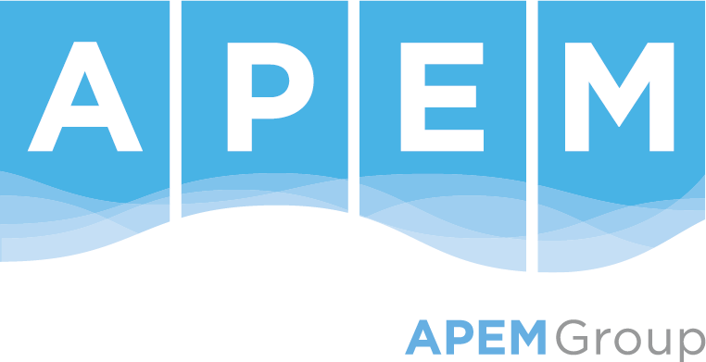

**Job Description**

**Role title: Senior Consultant - Water Resources Management**

**Reports to: Principal consultant**

**Grade: Senior Consultant**

**Sector: Water & Land**

**Division: Water Resources Management**

**Location: Flexible**

**Purpose/ Scope of role**

APEM’s Water Resources Planning team continues to expand and is currently undertaking exciting projects in water resources, hydrology, hydrometry, drought, environmental assessment and management.

This is a great opportunity to work on a range of water projects such as water company drought and water resources plans, regional water resources plans, drought permit applications, monitoring programmes, associated assessments e.g., WFD Compliance Assessment, HRA. The role forms part of a wider dynamic team of multi-disciplinary water and environmental experts that includes specialists in the fields of water resources, hydro-ecology, hydrology, geomorphology, water quality, aquatic and terrestrial ecology, environmental impact assessment and planning. You will use your technical skills to help design, optimise and analyse water management programmes for a portfolio of aquatic and ecology projects.

**What success looks like in this role**

In the first six months you will assist others in aspects of project management, tender production, and financial management across our portfolio of water management work. These will include technical inputs, analysis, reporting, business development, and client-facing capabilities, supported throughout by APEM’s highly experienced team of multi-disciplinary consultancy professionals.

In 12 months, you may be managing your own projects. You may have line management of consultants and have responsibility for quality of the work delivered by the team as well as contributing to mentoring, supporting and guidance. You will be providing expert advice in your area of expertise to a range of internal and external clients. You will be developing your own client network and actively winning new work. You will contribute to client meetings, site visits and field surveys where required.

**Key Responsibilities and accountabilities**

* To manage projects effectively to agreed time, budget and quality targets;
* To produce high quality work (including data analysis and report writing) within tight deadlines;
* To be able to prioritise your time and workload, as well as those of others to achieve deadlines;
* To be able to identify business development opportunities, including identifying, attending and presenting at relevant conferences and marketing events;
* To have contact with clients in respect of project requirements and active projects;
* To be involved in aspects of tender preparation including writing proposals, setting budgets, programmes and scope both alone, with other internal teams and in partnership with external organisations;
* To mentor, guide and develop more junior members of the team;
* To carry out any additional activities that may be reasonably required or requested.
* To take reasonable care for the health and safety of yourself and others; make use of the tools, equipment, training and resources; and actively engage with colleagues at all levels to contribute to the continuous improvement of health and safety management.
* Complete mandatory health and safety training modules and any that are specific to your role.

**Skills/ Knowledge/ Experience/ Qualifications**

**Essential**

* BSc or MSc degree in a relevant subject and ideally at least five years’ professional experience working across water resources management, drought planning, water related monitoring programmes and assessments e.g., WFD Compliance Assessment, HRA, Environmental Assessment Report (EAR), water cycle studies;
* Proven ability to plan and deliver analytical projects on time and within budget;
* Strong, creative problem-solving, organisational and analytical skills;
* A contemporary understanding of relevant key UK environmental legislation related to water resources planning, drought planning and associated environmental assessments;
* Excellent communication and report writing skills;
* A valid driving licence.
* Flexibility to manage changing priorities.

**Desirable**

* Membership of a relevant professional body;
* First Aid certification;
* A current CSCS card.

**We are involved in a diverse range of work and therefore would be interested in hearing from applicants who have any of the below skills. However, we do not expect all applicants to cover these topics.**

* Water resources planning (e.g., supply demand balance, drought management);
* Water risk and security;
* Hydrometric data and analysis;
* Resilience and water management;
* Sustainability assessments, water cycle studies;
* Water level management;
* Environmental assessments, including HRA, SEA, WFD, EAR;
* Climate resilience;
* Scheme appraisal;
* Regulatory support.

**Our Values**

Our most important assets are our people who work here. We all work as one team and rely on each other. We wish to create a working environment to which our people are proud to belong, by maintaining our values at the forefront of everything we do. These values are:

* Integrity – We do the right thing;
* Quality – Quality in everything;
* People - We care;
* Forward thinking – We focus on the future;
* Positivity – We believe we can;
* Fairness – We champion equality.

**Our WOW Factor**

When home became work, we learned that flexibility, understanding and balance allowed us all to move forward and grow together. So, no matter where you’re based, the hours you keep, the toddlers you have to entertain, or outside interests that help with your wellbeing, we’re committed to our Ways of Working (WOW) with each other so we can continue to be our best.

**You belong**

We recognise that everyone’s story is different. The opportunities, experiences and challenges faced in life shape who we are, and we understand that these are the things that make us individual and unique. Embracing our differences means we’re able to approach what we do from every angle.

Inspiration and insight can come from anywhere, and no matter your history or choices in life, we empower our people to be their best, so we can be our best, together. **We welcome the whole you.**